**“Workshop on Solar PV System and Panel Selection”**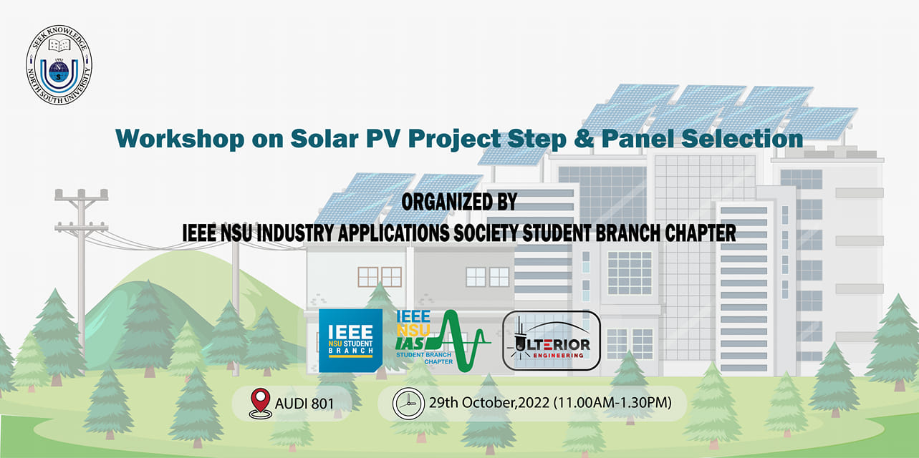

**Title: Workshop on Solar PV System and Panel Selection**

**Date:** 29th October 2022

**Time:** 11.00 am- 2.00 pm

**Venue:** Audi 801, North South University

**Organized by:**  IEEE NSU IAS Student Branch Chapter

**Event’s category**: Workshop

**Number of total participants:** 60

**Number of participated IEEE members**: 35

**Speaker details:**

**1. Training Instructor :**

Engr. Rafat Bin Ali,

CEO, Ulterior Engineering.

Ex-Project Manager, Tasisat Renewable Energy,Saudi Arabia.

Ex-Project Manager, Samasun International, Saudi Arabia.

Ex-System Technical Engineer, Delta Control, Saudi Arabia.

Certified Solar PV Engineer, Saudi Government.

Certified Delta Control Automation, George University Canada.

**2. Guest Speaker:**

Engr. Sayed Bin Osman

Chief Research & Development Officer,

Head of Robotics Department, Ulterior Engineering

Former Lecturer, Cox’s Bazar International University.

Former Project Coordinator, Chengdu High-tech Zone, China.

B.Sc. in EEE, IIUC

M.Sc. In Solid State Electronics, UESTC, China

**Workshop on Solar PV System and Panel Selection**

**IEEE NSU Industry Applications Society (IAS) Student Branch Chapter successfully** hosted the event entitled ***“Workshop on Solar PV System and Panel Selection”,*** in collaboration with ***‘Ulterior Engineering Intl’*** on 29th October, 2022. It was a lab workshop arranged for the students who are currently enrolled in the ECE department of North South University.

In this workshop, we had Engr. Rafat Bin Ali. He is the CEO & Co-founder of Ulterior Engineering Intl. He is also a certified Solar PV Engineer by the Saudi Government. Our guest speaker for this workshop was Engr. Sayed Bin Osman. He is the chief research & development officer, head of robotics department at Ulterior Engineering. We had Mr. Tarek Ibne Mizan sir as our special guest for this workshop. He is a senior lecturer at ECE department, North South University.

The workshop started approximately at 11.30 am. At first, Engr. Sayed Bin Osman introduced Ulterior Engineering Intl to the participants. He then talked about how engineers can shine in so many fields in this real world. Then our training instructor Engr. Rafat Bin Ali took over the session. He introduced many types of solar panels. Then he gave a descriptive idea how a person should choose the best solar panel for any project as panel selection is one of the most important things for a solar pv project. He gave an idea how temperature and many more factors affect solar panel systems. Then he talked about the effectiveness of the solar system in this environment and showed important data sheets regarding this topic.

This workshop was really interesting and helpful for the students who have curiosity about the solar pv system. The participants got huge information about the solar pv system and the current market situation around it. It was such an interactive session. Then a Q&A session was held where the speakers replied amazingly to the participants and shared their journey.

Finally, the token of appreciation was presented to the training instructor and guest speaker by our special guest Mr. Tarek Ibne Mizan sir. The Chairperson of IEEE North South University Industry Applications Society Student Branch Chapter then thanked the speakers, special guest, and participants, and with that, the event was concluded at 2.00 PM.